

**Process Management**

***Objective: In this lab you will exercise some of the concepts related to process creation, destruction and kernel threads by building a LKM called*** sleep_killer.

Reference: LKI/labs/Lab5 folder

1. sleep_killer should start a kernel thread and repeatedly poll for user-mode processes that are attempting to use the “sleep” command. Ex. “sleep 10 &” will run the sleep command in the background for 10 seconds and report when complete.



1. Once a sleep process is found, the sleep_killer module should first trace the process hierarchy back to the init process, which as we learned is the parent of all PIDs [1].

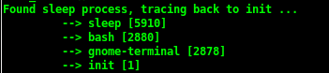

1. Finally sleep_killer should show these processes no mercy by killing them. We will go over signals in a later section, for now use the following function to kill the process:



1. Test your module by starting a sleep command in a separate terminal window and making sure it is automatically killed by your sleep_killer LKM. Your output should look similar to the following:

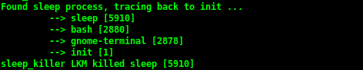

In a separate window a sleep command is started and automatically killed:

